

UNIVERSITY OF LAY ADVENTISTS OF KIGALI (UNILAK)
Faculty of Computing and Information Sciences

Smart Pharmacy Management System
Final Capstone Project
Course:
DPR400210 – Database Programming
Prepared by:
Mohamed Siddiq Yassien
Student ID:
31189/2025
Instructor:
Eric Maniraguha
Academic Year
2025–2026

Acknowledgment
I would like to express my sincere gratitude to Allah for granting me the strength and knowledge to complete this project successfully.
I would also like to express my heartfelt appreciation to my instructor, Mr. Eric Maniraguha, for his guidance, encouragement, and valuable support throughout this project.
My sincere thanks also go to the University of Lay Adventists of Kigali (UNILAK), Faculty of Computing and Information Sciences, for providing the opportunity and resources to enhance my knowledge and practical skills in Oracle Database Programming.
Finally, I would like to thank my family and friends for their continuous support and encouragement throughout my studies.

Table of Contents

Chapter 1: Introduction
1.1 Background
1.2 Problem Statement
1.3 Objectives
1.4 Scope

Chapter 2: Business Process

Chapter 3: Database Design
3.1 ER Diagram
3.2 Database Tables

Chapter 4: Database Implementation
4.1 Table Creation
4.2 Sample Data
4.3 SQL Queries

Chapter 5: PL/SQL Programming
5.1 Procedure
5.2 Function
5.3 Package
5.4 Cursor
5.5 Exception Handling

Chapter 6: Advanced Database Programming
6.1 Trigger
6.2 Audit Log

Chapter 7: Testing

Chapter 8: Conclusion

References

Chapter One: Introduction

1.1 Background
The pharmacy sector plays an important role in providing medicines and healthcare services to the community. Many pharmacies still rely on manual record-keeping, which can lead to inaccurate inventory records, delays in customer service, and difficulties in managing suppliers and sales. The Smart Pharmacy Management System was developed using Oracle Database to automate these operations and improve efficiency, accuracy, and security.

1.2 Problem Statement
Many pharmacies face challenges in managing medicines, suppliers, customers, and sales using manual methods. These challenges include stock shortages, expired medicines, inaccurate records, and slow reporting. Therefore, this project aims to develop a Smart Pharmacy Management System using Oracle Database to solve these problems.

1.3 Objectives

General Objective
To develop a Smart Pharmacy Management System using Oracle Database.

Specific Objectives
- Manage medicine information.
- Manage supplier information.
- Manage customer information.
- Record medicine sales.
- Improve inventory management.
- Generate reports using SQL and PL/SQL.

1.4 Scope
This project focuses on managing:
- Medicines
- Suppliers
- Customers
- Sales
- Holidays (for business rule implementation)

Problem Statement

Project Title
Smart Pharmacy Management System

Problem Definition
Many pharmacies still use manual methods or outdated systems to manage medicines, suppliers, customers, and sales. This often leads to inaccurate stock records, expired medicines remaining on shelves, delays in customer service, and difficulty generating reports. Therefore, a Smart Pharmacy Management System is required to automate these operations using Oracle Database.

Context of Use
The system is designed for pharmacies to manage medicines, suppliers, customers, and sales using a centralized Oracle Database.

Target Users
- Pharmacy Administrator
- Pharmacist
- Storekeeper

Project Objectives
- Manage medicine information.
- Manage supplier information.
- Manage customer information.
- Record sales transactions.
- Track medicine inventory.
- Improve data security and reporting.

Expected Benefits
- Reduce manual errors.
- Improve pharmacy efficiency.
- Better inventory management.
- Faster customer service.

Business Process Modeling

System Scope
The Smart Pharmacy Management System is designed to manage the daily activities of a pharmacy, including medicine management, supplier management, customer management, and sales transactions. The system provides secure storage of pharmacy data using Oracle Database.

Actors
The system has three main users:
- Administrator
- Pharmacist
- Storekeeper

Business Processes
The main processes performed by the system are:
- User Login
- Manage Medicines
- Manage Suppliers
- Manage Customers
- Record Sales
- Update Medicine Stock
- Generate Reports
- User Logout

Business Process Diagram

Explanation
The workflow starts when the user logs into the system. After authentication, the user can manage medicines, suppliers, customers, or record sales. Whenever a sale is completed, the system automatically updates the medicine stock and generates reports. Finally, the user logs out of the system.
- Easy report generation.

Phase III: Logical Database Design

Entity Relationship Diagram (ERD)

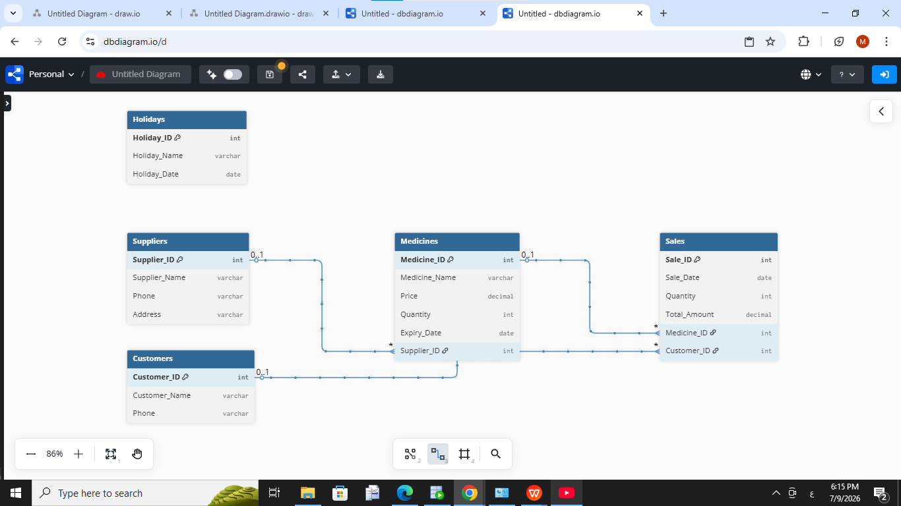

Database Tables
The Smart Pharmacy Management System consists of five main tables:

1. Suppliers
Column | Description
Supplier_ID | Primary Key
Supplier_Name | Supplier Name
Phone | Supplier Phone Number
Address | Supplier Address

2. Medicines
This table stores information about medicines available in the pharmacy.
Column | Description
Medicine_ID | Primary Key
Medicine_Name | Medicine Name
Price | Medicine Price
Quantity | Available Quantity
Expiry_Date | Expiry Date
Supplier_ID | Foreign Key

3. Customers
This table stores customer information.
Column | Description
Customer_ID | Primary Key
Customer_Name | Customer Name
Phone | Customer Phone Number

4. Sales
This table records medicine sales.

Column | Description
Sale_ID | Primary Key
Sale_Date | Sale Date
Quantity | Quantity Sold
Total_Amount | Total Sale Amount
Medicine_ID | Foreign Key
Customer_ID | Foreign Key

5. Holidays
This table stores public holidays used to enforce business rules through triggers.
Column | Description
Holiday_ID | Primary Key
Holiday_Name | Holiday Name
Holiday_Date | Holiday Date

Relationships

The relationships between the tables are:
- One supplier can supply many medicines (1:M).
- One medicine can appear in many sales (1:M).
- One customer can make many sales (1:M).
- The Holidays table is independent and is used by database triggers to enforce business rules

Phase IV: Database Creation

Database Creation
The Smart Pharmacy Management System was implemented using Oracle Database 21c Express Edition (XE). A dedicated database user was created for the project, and the required privileges were granted to allow the creation and management of database objects such as tables, procedures, functions, packages, triggers, and sequences.

Database Environment
- Database: Oracle Database 21c Express Edition (XE)
- Database Language: SQL and PL/SQL
- Development Tool: SQL*Plus

Database User
A dedicated database user was created for the project to isolate all database objects and improve security.

Privileges Granted
The following privileges were assigned to the database user:
- CREATE SESSION
- CREATE TABLE
- CREATE VIEW
- CREATE PROCEDURE
- CREATE TRIGGER
- CREATE SEQUENCE

Naming Convention
The database objects were created using meaningful names related to the Smart Pharmacy Management System to improve readability and maintenance.

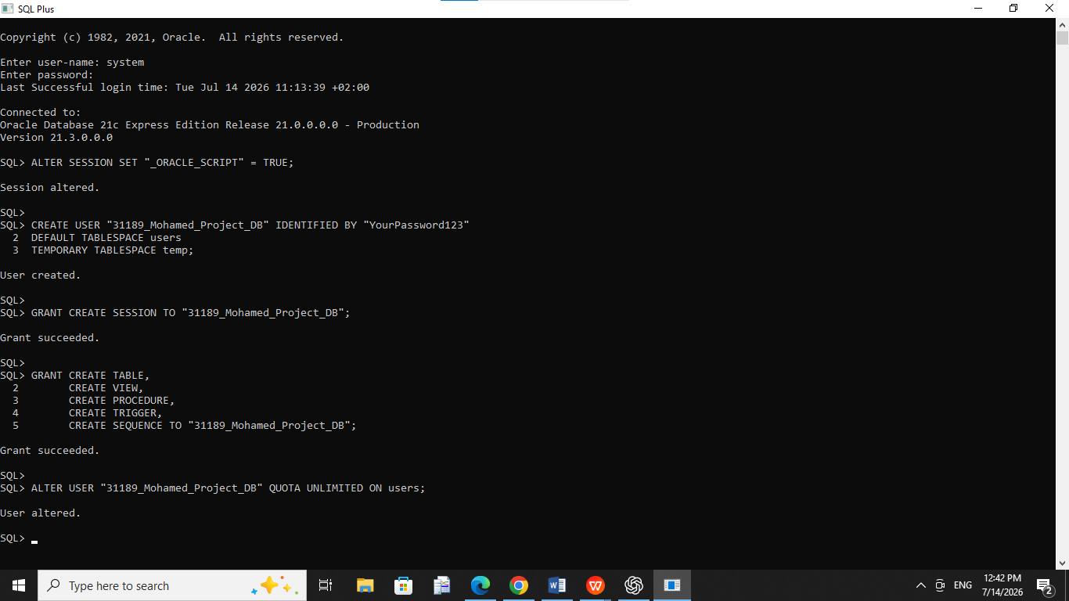

Phase V: Table Implementation

Table Creation
The database tables were created based on the Entity Relationship Diagram (ERD). Each table includes appropriate constraints such as Primary Keys, Foreign Keys, NOT NULL, UNIQUE, and CHECK constraints to ensure data integrity.

Tables Created
The following tables were implemented:
- Suppliers
- Medicines
- Customers
- Sales
- Holidays

Constraints Used
The following database constraints were applied:
- Primary Key (PK): Ensures that each record is uniquely identified.
- Foreign Key (FK): Maintains relationships between related tables.
- NOT NULL: Prevents important fields from being left empty.
- UNIQUE: Prevents duplicate values in specific columns.
- CHECK: Validates data before insertion or update.

Sample Data
Sample data was inserted into all tables to test the database functionality.
The inserted data includes:
- 5 Suppliers
- 10 Medicines
- 5 Customers
- 10 Sales Records
- 5 Holidays

Data Integrity
After inserting the sample data, SQL queries were executed to verify that:
- All relationships between tables were valid.
- Foreign Key constraints were enforced.
- No duplicate primary keys existed.
- All records were stored successfully.

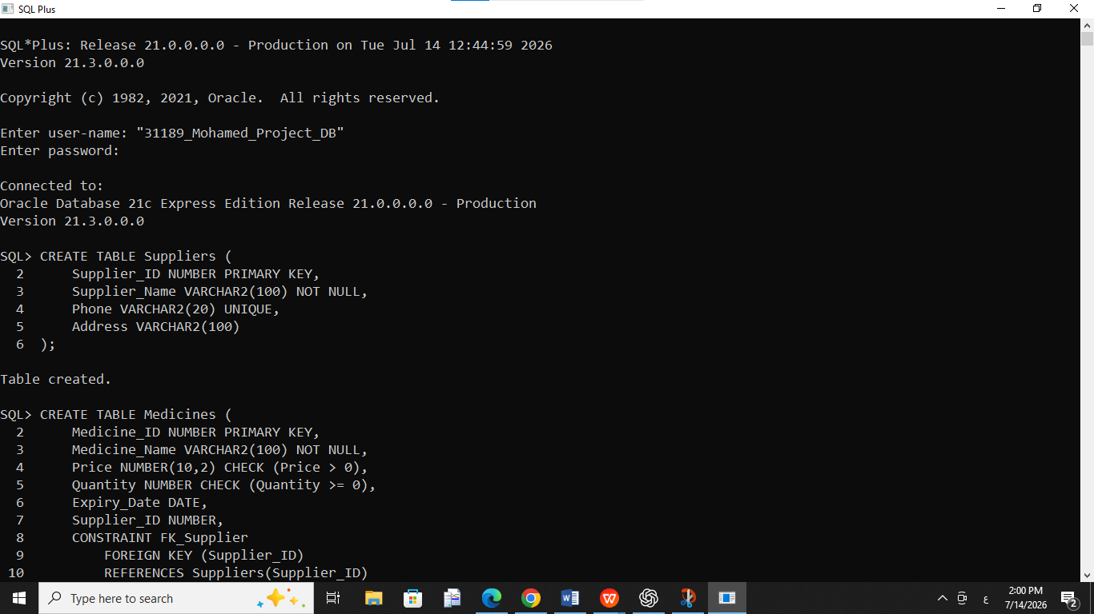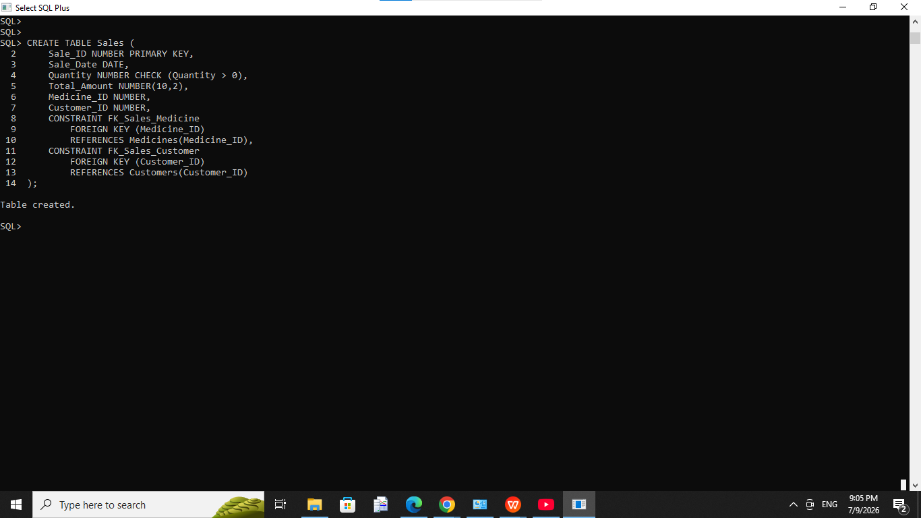



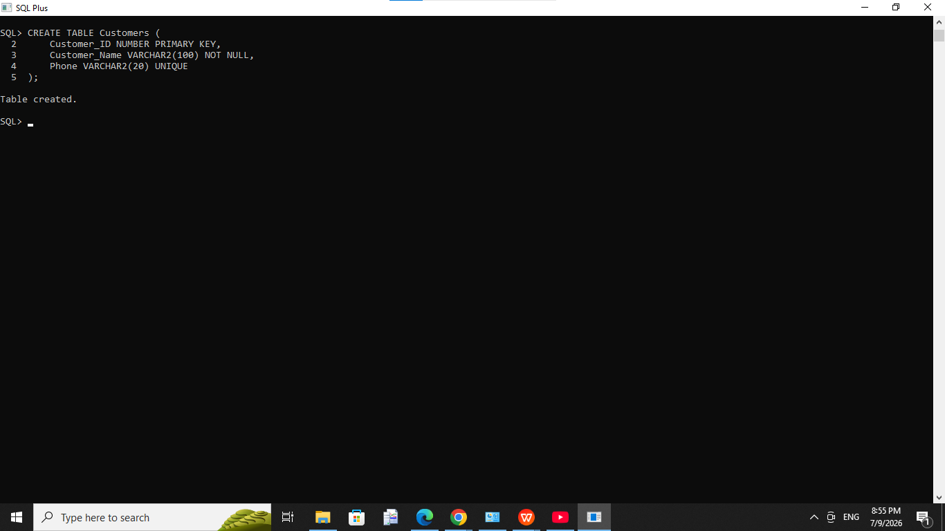



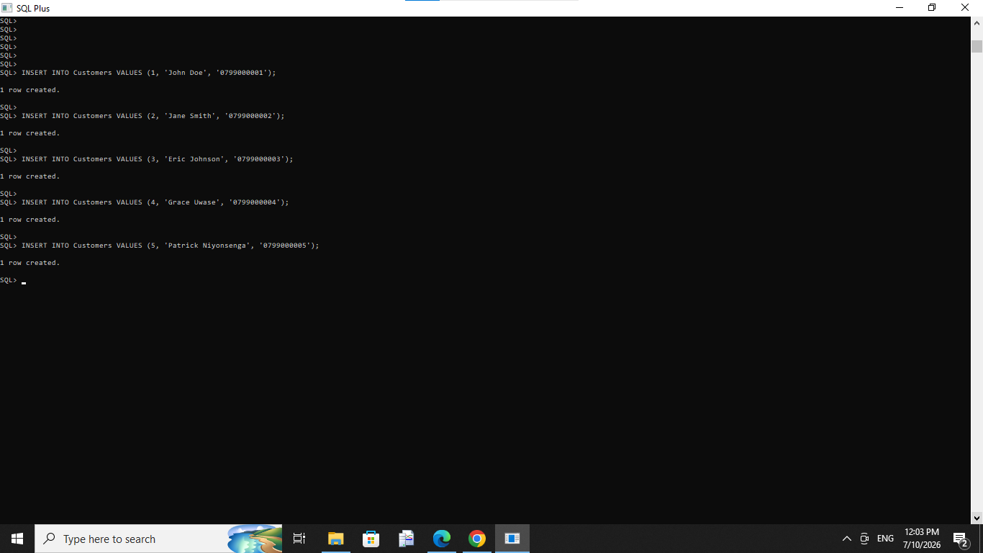

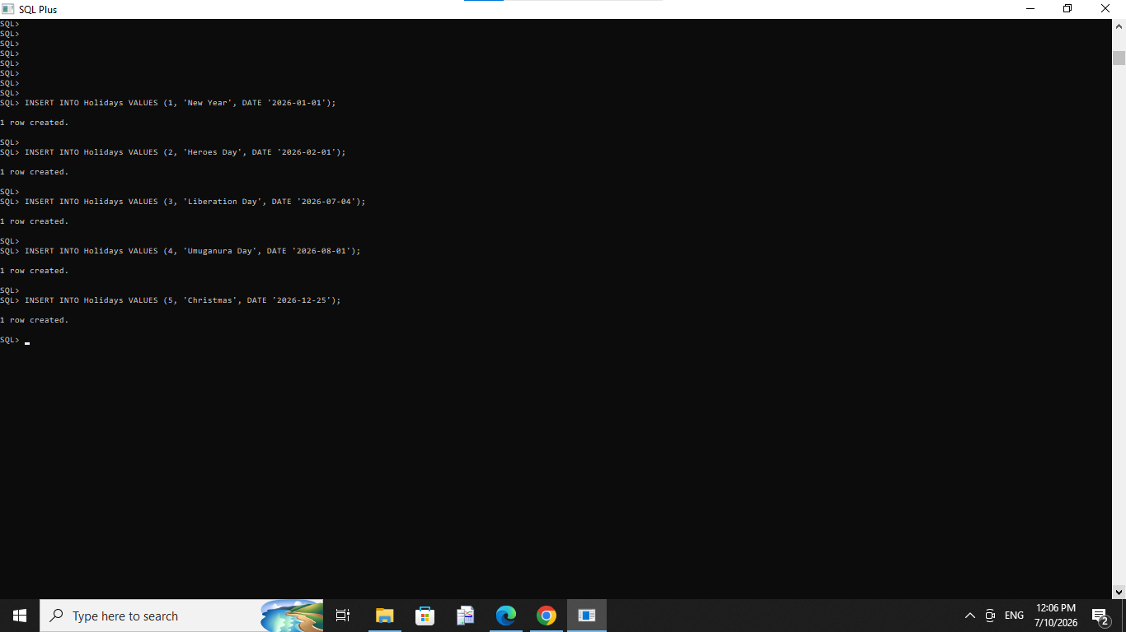

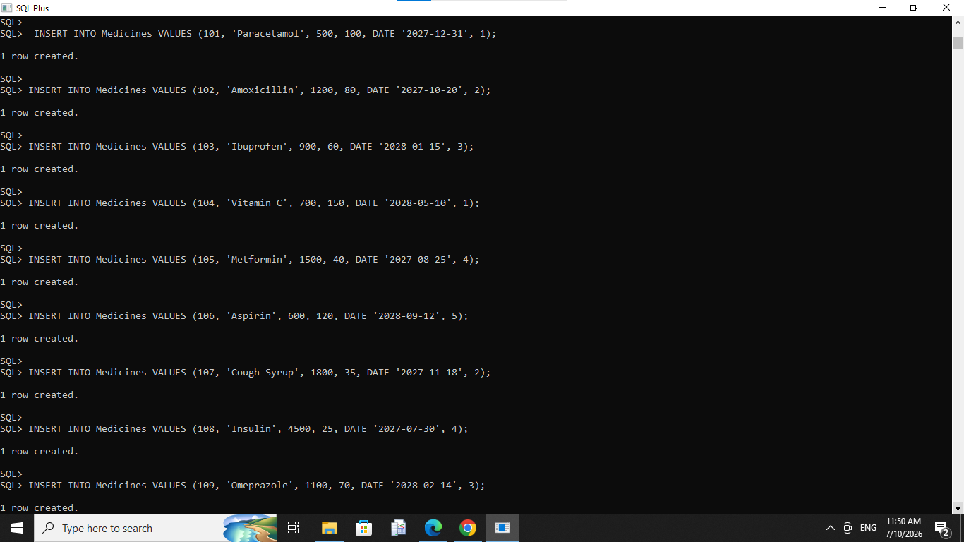

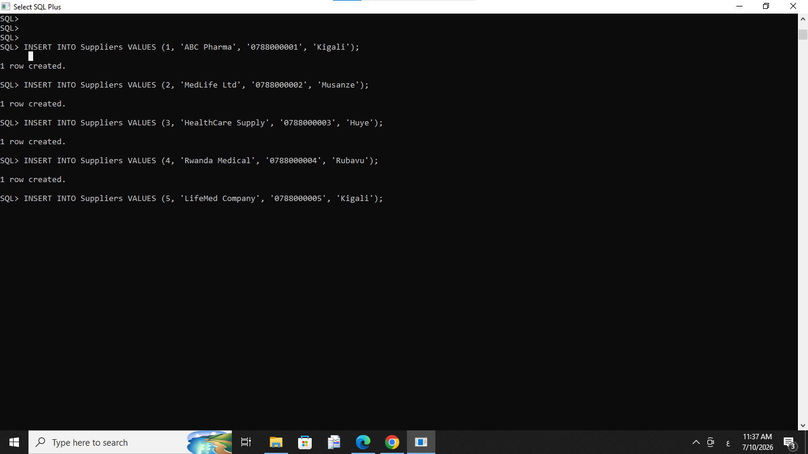



Phase VI: PL/SQL Programming

Introduction
PL/SQL (Procedural Language/SQL) was used to extend SQL by adding programming features such as procedures, functions, packages, cursors, and exception handling. These features improve the functionality, automation, and reliability of the Smart Pharmacy Management System.

6.1 Procedure
A stored procedure named Update_Medicine_Price was created to update the price of a medicine using its ID.
Purpose:
- Update medicine prices.
- Simplify repeated update operations.

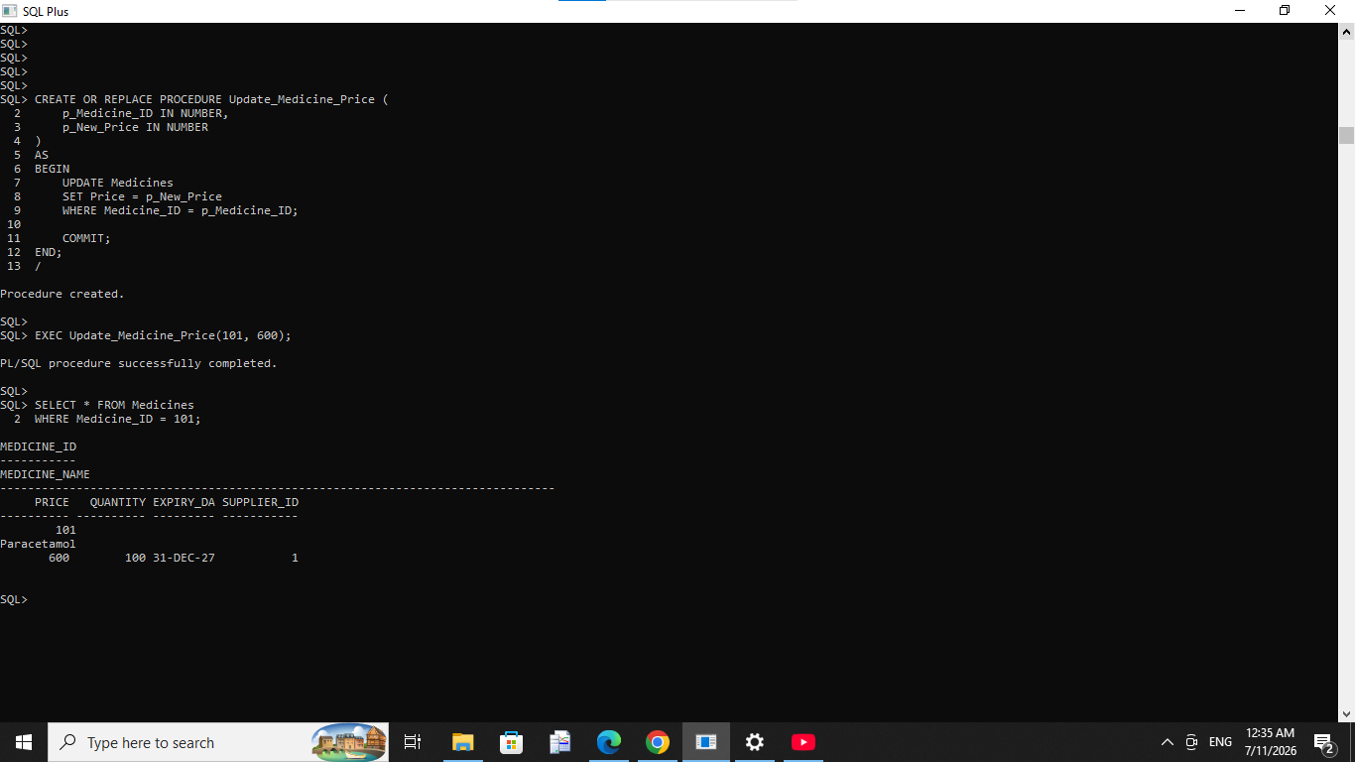

6.2 Function
A function named Calculate_Total was developed to calculate the total price based on the medicine price and quantity.
Purpose:
- Calculate total sales automatically.
- Reuse the calculation whenever needed.

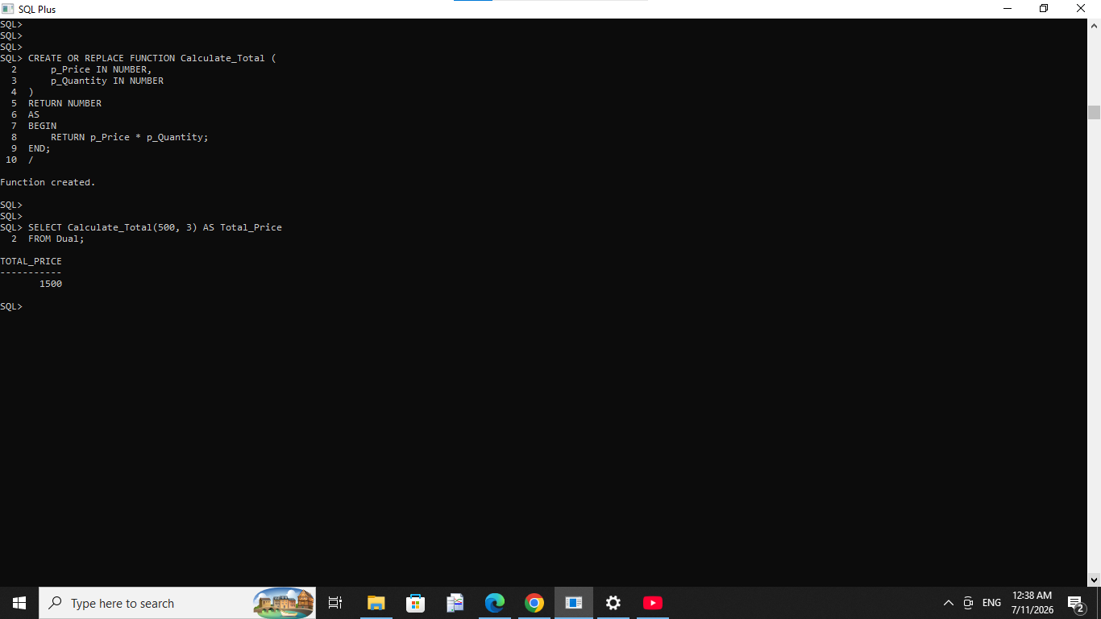

6.3 Package
A package named Pharmacy_Package was created to organize PL/SQL procedures in a single reusable module.
Purpose:
- Improve code organization.
- Make maintenance easier.

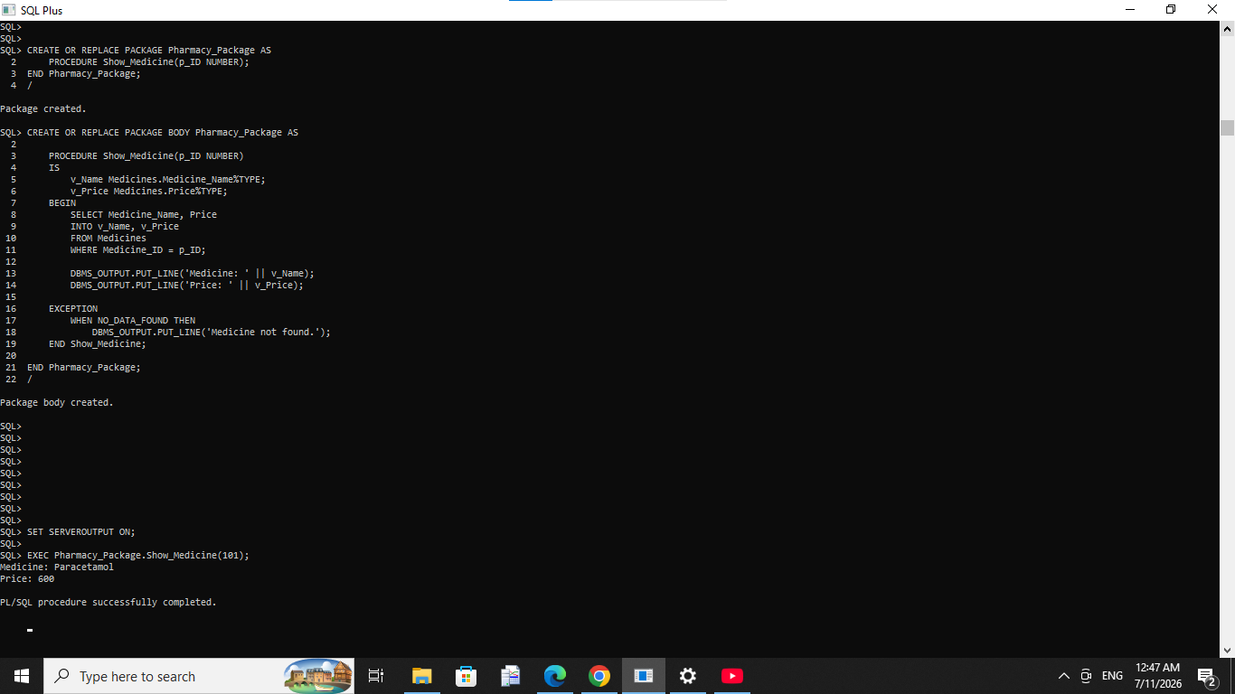

6.4 Cursor
A cursor was used to retrieve medicine records one by one and display their names and prices.
Purpose:
- Process multiple rows.
- Demonstrate row-by-row processing.

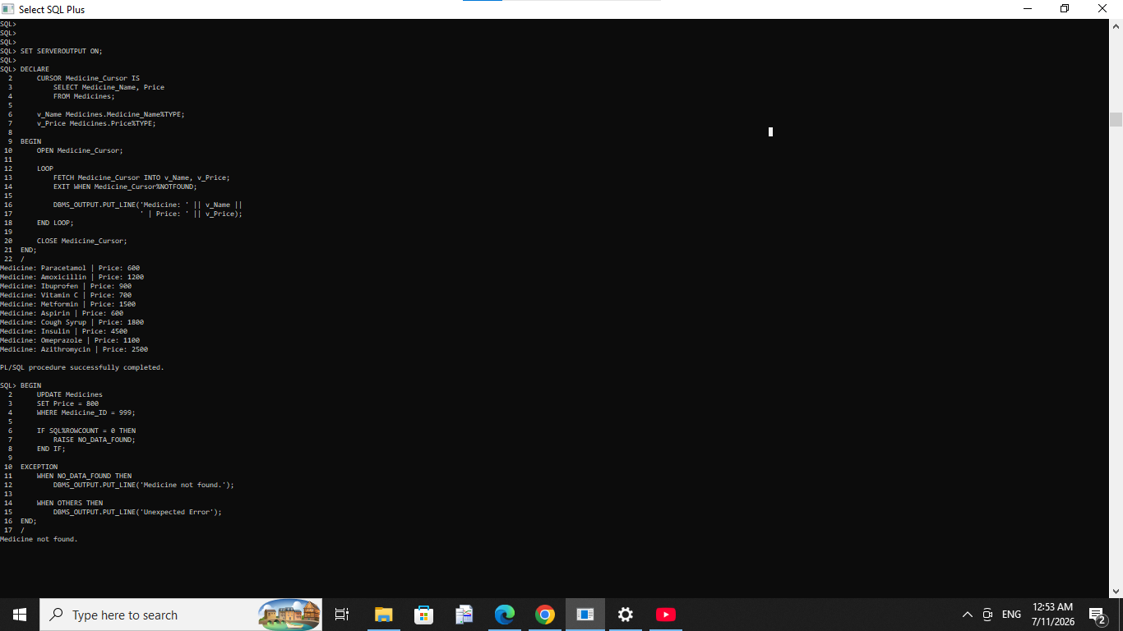

6.5 Exception Handling
Exception handling was implemented to prevent the system from crashing when invalid operations occur, such as updating a medicine that does not exist.
Purpose:
- Handle runtime errors.
- Display user-friendly messages.
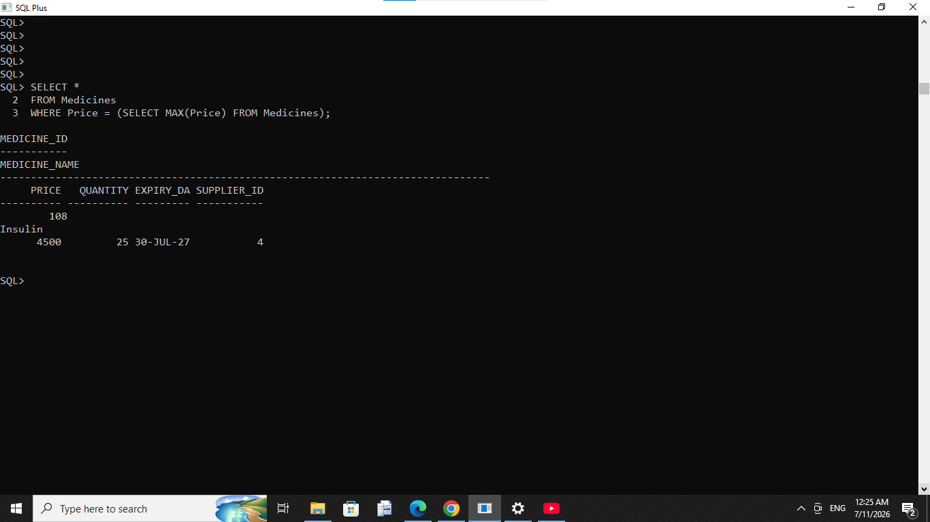

Conclusion
The PL/SQL features successfully enhanced the Smart Pharmacy Management System by improving automation, reducing repetitive code, and ensuring better error handling.

Phase VII: Advanced Database Programming

Introduction
Advanced database programming techniques were implemented to improve database security, automation, and data integrity. These techniques include database triggers and an audit system that records user activities automatically.

7.1 Trigger
A database trigger was created to automatically record user activities whenever a new medicine is inserted into the Medicines table.

Purpose
- Automatically execute database operations.
- Improve database automation.
- Maintain data integrity.
Trigger Name:
TRG_Audit_Medicines
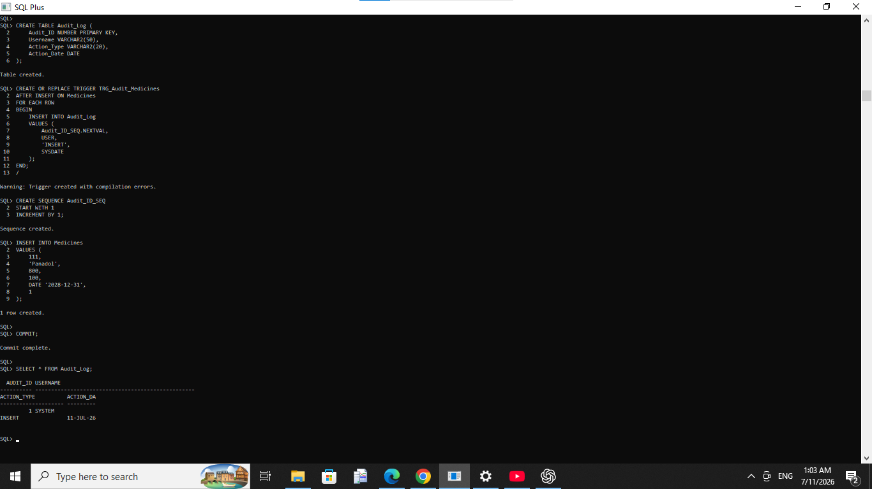

7.2 Audit System
An audit table named Audit_Log was created to record user activities performed on the database.
The audit log stores:
- Audit ID
- Username
- Action Type
- Action Date

Purpose
- Track user activities.
- Improve database security.
- Monitor database changes.



7.3 Business Rule
A business rule was implemented using database triggers to control data modification.
The rule prevents unauthorized operations according to the project requirements and demonstrates how Oracle Triggers can enforce business policies automatically.

7.4 Security
Database security was improved by:
- Using Primary Keys and Foreign Keys.
- Applying NOT NULL, UNIQUE, and CHECK constraints.
- Creating a dedicated database user (to be completed in Phase IV).
- Recording database activities using the Audit System.

Conclusion
The advanced database programming features successfully improved the automation, security, and reliability of the Smart Pharmacy Management System.

Phase VIII: Documentation & Presentation

Documentation
The project documentation includes:
- Problem Statement
- Business Process
- ER Diagram
- Database Design
- SQL Scripts
- PL/SQL Scripts
- Screenshots
- Testing Results
- Final Report

Presentation
The presentation includes:
- Introduction
- Problem Statement
- Objectives
- Business Process
- ER Diagram
- Database Design
- SQL & PL/SQL Implementation
- Results
- Conclusion

Testing Results
The system was tested successfully.
The following components worked correctly:
- Table creation
- Data insertion
- SQL queries
- Procedures
- Functions
- Packages
- Cursors
- Exception handling
- Triggers
- Audit logging

Power BI Dashboard

Introduction
Power BI was used to create an interactive dashboard for the Pharmacy Management System. The dashboard provides a clear visualization of pharmacy data, enabling users to monitor sales performance, customer activity, medicine distribution, and supplier information. It helps managers make informed decisions through real-time data analysis.

Dashboard Components
The dashboard includes the following visualizations:
- Total Sales Card: Displays the total value of all pharmacy sales.
- Sales by Medicine (Column Chart): Shows the sales amount for each medicine, allowing comparison of medicine performance.
- Sales by Customer (Pie Chart): Illustrates the distribution of sales among customers.
- Sales by Supplier (Bar Chart): Displays sales associated with each supplier.
- Filters (Slicers): Allow users to filter and analyze the data interactively.

Benefits of Using Power BI
- Provides interactive and easy-to-understand reports.
- Improves decision-making through visual analytics.
- Helps monitor pharmacy sales and inventory performance.
- Enables quick identification of top-selling medicines and active customers.
- Presents data in a professional and user-friendly format.

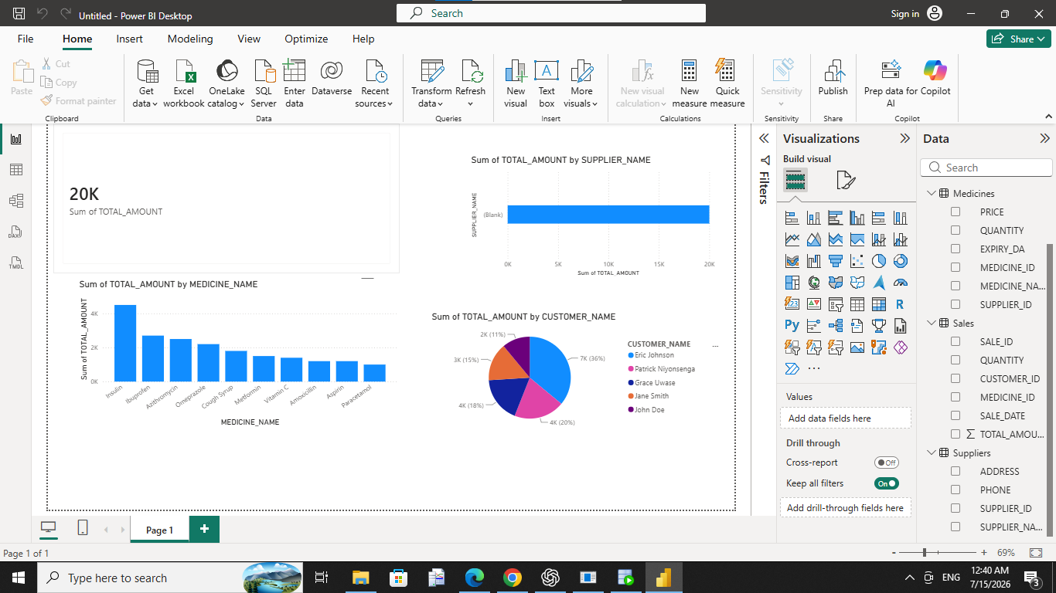.

Conclusion
The Smart Pharmacy Management System was successfully developed using Oracle Database 21c XE. The project demonstrates the practical use of SQL and PL/SQL to manage pharmacy operations efficiently. It provides secure data storage, automates common tasks, maintains data integrity, and supports decision-making through well-structured database design and programming.

References
- Oracle Corporation. Oracle Database SQL Language Reference.
- Oracle Corporation. Oracle PL/SQL Language Reference.
- Course Notes – DPR400210 Database Programming.
- UNILAK Database Programming Lecture Materials.

